- RE-DRAFT v2 -

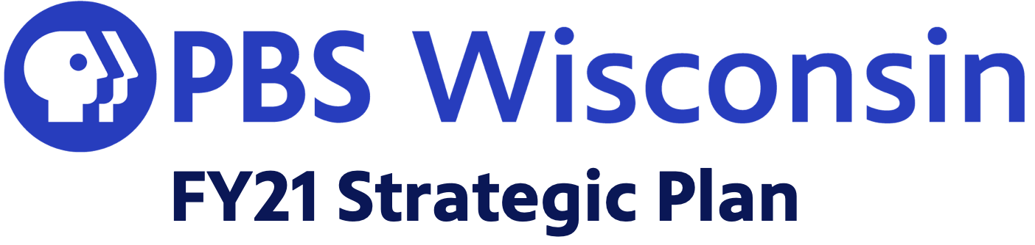

PBS Wisconsin FY21 Strategic Vision

- PBS Wisconsin is an essential, trusted community organization providing access and connectivity to the diverse communities of Wisconsin by creating and delivering meaningful content and inspiring community engagement.

- PBS Wisconsin is a vital part of the educational ecosystem of our state, focusing on early learners, PK-12 education, and community education.

- PBS Wisconsin remains sustainable through innovative fundraising, prudent stewardship of resources, and continuously demonstrating the impact of our work, and thus our value, to audiences, stakeholders, and the communities we serve.

- PBS Wisconsin’s mission is only fulfilled when we engage diverse voices in our work including management, planning, building community partnerships, and content creation.

DEPARTMENT: FY21 UPDATED PRIORITIES

A. Build and Engage Audiences
- Deepen engagement with the people of our state and deepen collaboration with strategic content partners.

  - Increase overall viewing and engagement across broadcast and other digital distribution platforms, emphasizing Wisconsin content.

  - Stimulate participation across Wisconsin through community engagement using multiple platforms and partnerships.

  - Establish and sustain relationships with diverse community partners that improve our work, diversify voices for our audiences, and advance our shared mission.

  - Partner with Wisconsin Public Radio, the Educational Communications Board, the University of Wisconsin, and other organizations to enhance reach, service, and community impact.

    - Department Priorities here

- Create, acquire, and deliver content to engage audiences on evolving distribution platforms.
  - Experiment with new models of content creation, promotion, and distribution.

  - Set goals, evaluate, and reinvent how we create and distribute content.

    - Department Priorities here

- Deepen Engagement with PK-12 educators, parents, and educational partners, and build PBS Wisconsin's reputation as an essential contributor to Wisconsin's educational ecosystem.
  - Create, curate, and activate high quality digital media resources to meet Wisconsin learner and educator needs.

  - Activate communities of learning through partnerships, professional development, and equitable access to resources.

  - Increase public appreciation for PK-12 educators and awareness of educational systems and best practices.

  - Increase and support Wisconsin educators' awareness, proficiency and implementation of culturally relevant and anti-racist educational best practices and curricular tools.

    - Department Priorities here

- Build a foundation for the expansion of Early Learning & Adult and Community Education.
  - Leverage national content from PBS Kids/Ready to Learn, build local training and engagement, and experiment with new technologies to support early learners, caregivers, and families.

  - Be intentional about the role of racial perspective in how audiences are engaged, media is used and curated, and partnerships are developed

    - Department Priorities here

B. Diversity, Equity and Inclusion
- Be an organization where all staff and volunteers feel supported, connected, and valued; and each person is empowered to innovate, share their voice, develop their potential, and bring their full self.

    - Department Priorities here

- Recruit and retain diverse, culturally engaged staff.

    - Department Priorities here

- Foster challenging conversations about how we work, how we include diverse voices, and how we recognize and dismantle barriers and systems that exclude.

    - Department Priorities here

- Prioritize projects and partnerships that include, highlight and appreciate diverse cultures and life experiences.

    - Department Priorities here

- Welcome and actively find opportunities for the community to engage in, inform, and partner in our work.

    - Department Priorities here

C. Fund Development and Sustainability
- Strengthen and diversify fundraising.

    - Department Priorities here

- Nurture a spirit of stewardship throughout the organization.

    - Department Priorities here

- Earn appreciation and support from audiences consuming content on our many platforms.
  - Communicate impact and appreciation through continual proof of performance, and advocacy, with a disciplined, creative, and energetic branding and marketing approach.

    - Department Priorities here

D. Continuous Improvement
- Foster and support innovation, investing for the long term.

  - Prioritize experimentation and trying new things.

  - Continue developing cross-functional teams and improved project management models.

  - Invest in upgrading our work tools and facilities.

    - Department Priorities here

- Evaluation and Measurement
  - Improve goal setting, evaluation, and measurement practices, tools, and methodologies.

  - Review our policies, projects, and partnerships for inclusion of BIPOC voices

    - Department Priorities here

- Professional Development
  - Cultivate a learning environment by investing time and resources in professional growth focused on organizational sustainability, technological advances, adaptability, and inclusivity.

  - Develop a thoughtful, structured growth model that includes opportunities for early career staff to grow at PBS Wisconsin, and new work models that allow the flexibility to work with emerging talent

    - Department Priorities here

